**Prerequisites**

Make sure you have the following installed:

* Java
* Maven
* Tomcat
* Git

**1. Log in to the EC2 instance and install required packages**

First, connect to your Amazon Linux instance and install the necessary packages.

sudo yum update -y

sudo yum install git -y

sudo yum install java-21-amazon-corretto-devel.x86_64 -y

sudo yum install maven-amazon-corretto21.noarch -y

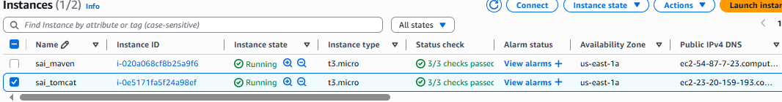

# Check Git version

git --version

# Example output: git version 2.47.1

# Check Maven version

mvn --version

# Example output: Apache Maven 3.8.4 (Red Hat 3.8.4-3.amzn2023.0.5)

# Java version: 21.0.6, vendor: Amazon.com Inc.

# Check Java version

java --version

# Example output: openjdk 21.0.6 2025-01-21 LTS

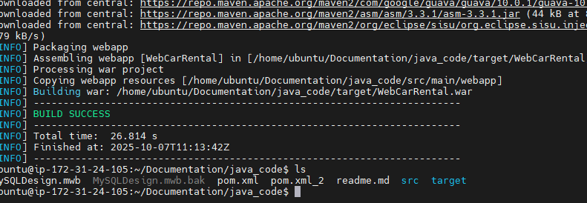

#### Modify context.xml files to allow external access (not just localhost):

find /opt/apache-tomcat-9.0.100 -name context.xml

# Edit the following files:

vi /opt/apache-tomcat-9.0.100/webapps/host-manager/META-INF/context.xml

vi /opt/apache-tomcat-9.0.100/webapps/manager/META-INF/context.xml

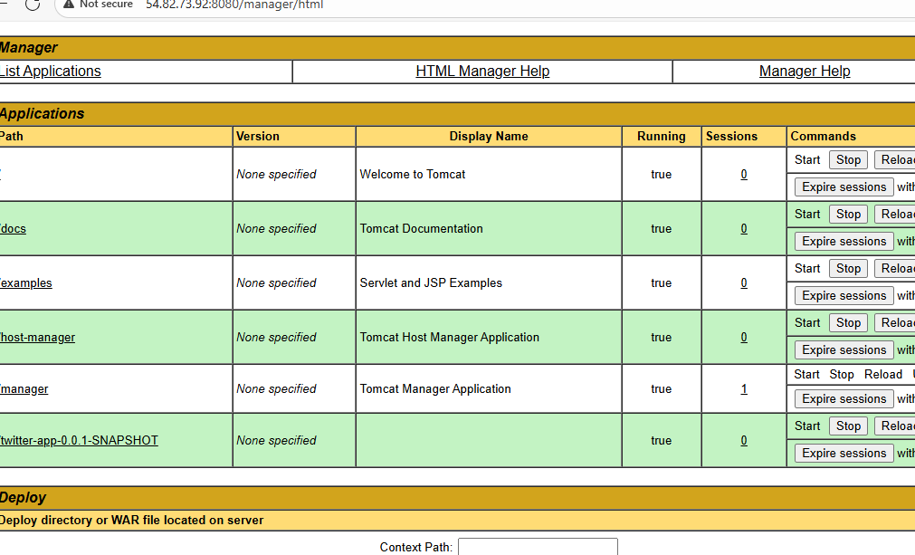

### Start the Tomcat server

cd /opt/apache-tomcat-9.0.100/bin

sudo chmod 755 *.sh

sudo ./startup.sh

Check that Tomcat started successfully:

ps -ef | grep tomcat

[root@ip-172-31-17-119 ~]# ps -ef |grep tomcat

root 28542 1 0 16:36 pts/1 00:00:40 /usr/bin/java -Djava.util.logging.config.file=/opt/apache-tomcat-9.0.100/conf/logging.properties -Djava.util.logging.manager=org.apache.juli.ClassLoaderLogManager -Djdk.tls.ephemeralDHKeySize=2048 -Djava.protocol.handler.pkgs=org.apache.catalina.webresources -Dsun.io.useCanonCaches=false -Dorg.apache.catalina.security.SecurityListener.UMASK=0027 -Dignore.endorsed.dirs= -classpath /opt/apache-tomcat-9.0.100/bin/bootstrap.jar:/opt/apache-tomcat-9.0.100/bin/tomcat-juli.jar -Dcatalina.base=/opt/apache-tomcat-9.0.100 -Dcatalina.home=/opt/apache-tomcat-9.0.100 -Djava.io.tmpdir=/opt/apache-tomcat-9.0.100/temp org.apache.catalina.startup.Bootstrap start

root 35804 35677 0 18:13 pts/3 00:00:00 /usr/bin/vim /opt/apache-tomcat-9.0.100/webapps/manager/META-INF/context.xml

root 36356 36271 0 18:27 pts/5 00:00:00 grep --color=auto tomcat

### Build the Application

[INFO] Building war: /root/CarRental/target/WebCarRental.war

[INFO] ------------------------------------------------------------------------

[INFO] BUILD SUCCESS

[INFO] ------------------------------------------------------------------------

[INFO] Total time: 1.615 s

[INFO] Finished at: 2025-04-09T17:19:35Z

[INFO] ------------------------------------------------------------------------

After the build completes, you should see something like this in the target/ directory:

[root@ip-172-31-17-119 CarRental]# cd target/

[root@ip-172-31-17-119 target]# ll

total 3932

drwxr-xr-x. 8 root root 82 Apr 9 17:19 WebCarRental

-rw-r--r--. 1 root root 4025158 Apr 9 17:19 WebCarRental.war

drwxr-xr-x. 3 root root 186 Apr 9 17:18 classes

drwxr-xr-x. 3 root root 25 Apr 9 17:18 generated-sources

drwxr-xr-x. 2 root root 28 Apr 9 17:19 maven-archiver

drwxr-xr-x. 3 root root 35 Apr 9 17:18 maven-status

[root@ip-172-31-17-119 target]# cp WebCarRental.war /opt/apache-tomcat-9.0.100/webapps/

### Deploy the Application to Tomcat

cp /root/CarRental/target/*.war /opt/apache-tomcat-9.0.100/webapps/

ll /opt/apache-tomcat-9.0.100/webapps/

[root@ip-172-31-17-119 target]# ll /opt/apache-tomcat-9.0.100/webapps/

total 3964

drwxr-xr-x. 3 root root 16384 Feb 13 11:29 ROOT

drwxr-x---. 8 root root 82 Apr 9 17:20 WebCarRental

-rw-r--r--. 1 root root 4025158 Apr 9 17:20 WebCarRental.war

drwxr-xr-x. 16 root root 16384 Feb 13 11:29 docs

drwxr-xr-x. 7 root root 99 Feb 13 11:29 examples

drwxr-xr-x. 6 root root 79 Feb 13 11:29 host-manager

drwxr-xr-x. 6 root root 114 Feb 13 11:29 manager

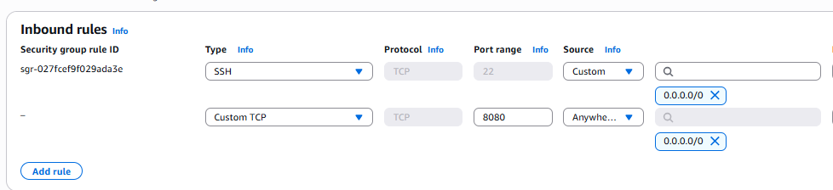

### Restart Tomcat

cd /opt/apache-tomcat-9.0.100/bin

sudo ./shutdown.sh

sudo ./startup.sh

check in server browser by using 8080 port number

